Control Scheme Updates
NOTE: Whenever possible, don’t delete previous systems and add a debug option to turn off these new features.

UI 1
Tasks 3
Low Powered Shots not registering 4
Tasks 4
Aiming Circle Speed 4
Task 4
Aiming Circle Relative Size 4
Aiming Circle Acceleration 4
Task 5
Control lag 5
Tasks 5
Yard Meter 5
Tasks 5
Max Power missing 1% while using Putter 5
Tasks 6
Reduce Randomizing factor 6
Tasks 6
Flight Path 6
Tasks 7
Direction 7
Tasks 7
Randomizer 7
Tasks 7
All tasks in order of priority 7

UI
Our current control scheme feels harder to use than it really is. After thinking about it for a bit, I believe the main issue lies in our UI. Mechanically we are not doing something much different than Neko Golf, but presenting it in a different and unintuitive way.

Currently we have 2 circles around our target ball with no clear indication of what they represent. Furthermore, the “inner” circle has a bigger exclusive area than the outer circle, which goes against what one would expect if hitting in the inner circle would result in a better shot (this is not accounting for acceleration of the Aiming Circle, if it has any).

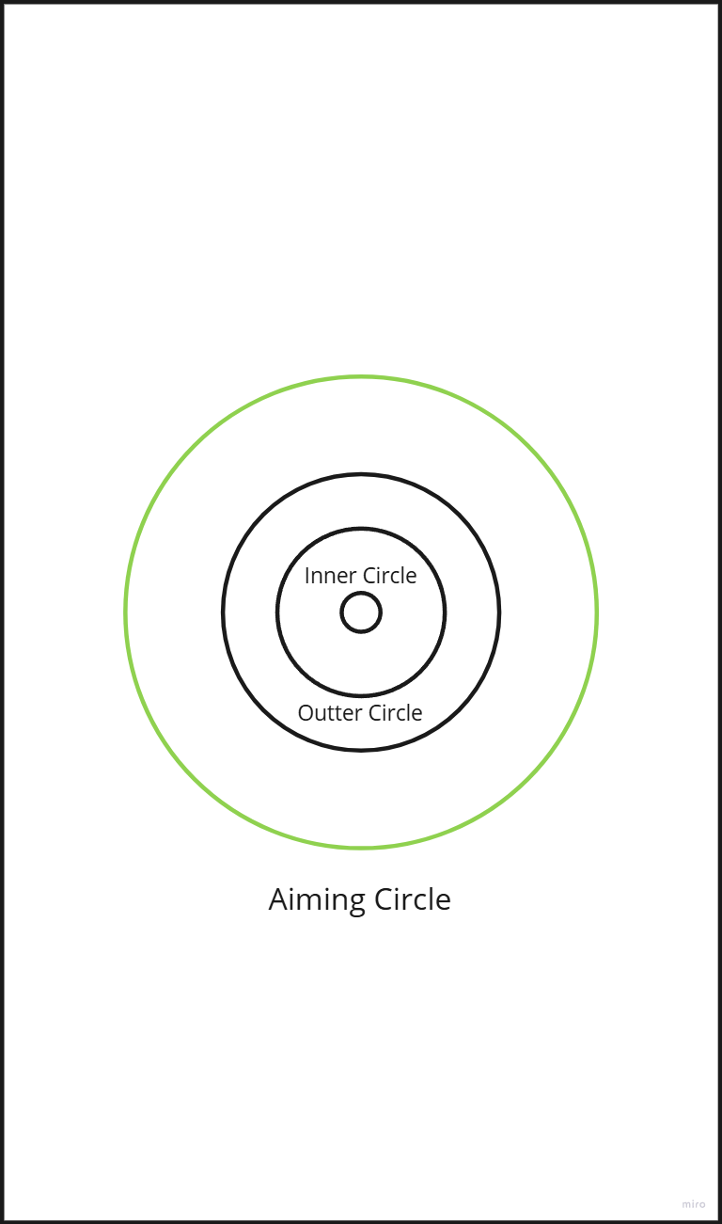

I have 3 proposals of UI to fix this, which I’ll present in terms of ease of implementation.

Colored Circles
2 change to current functionality.

- The Aiming Reticle changes color from Red to Yellow to Green to Blue (blue is perfect shot and should highlight the ball itself with an effect, colo is just tentative)
- The Outer Circle is bigger than the Inner Circle, which of course is bigger than the Ball

A shot window loop will then look something like this:
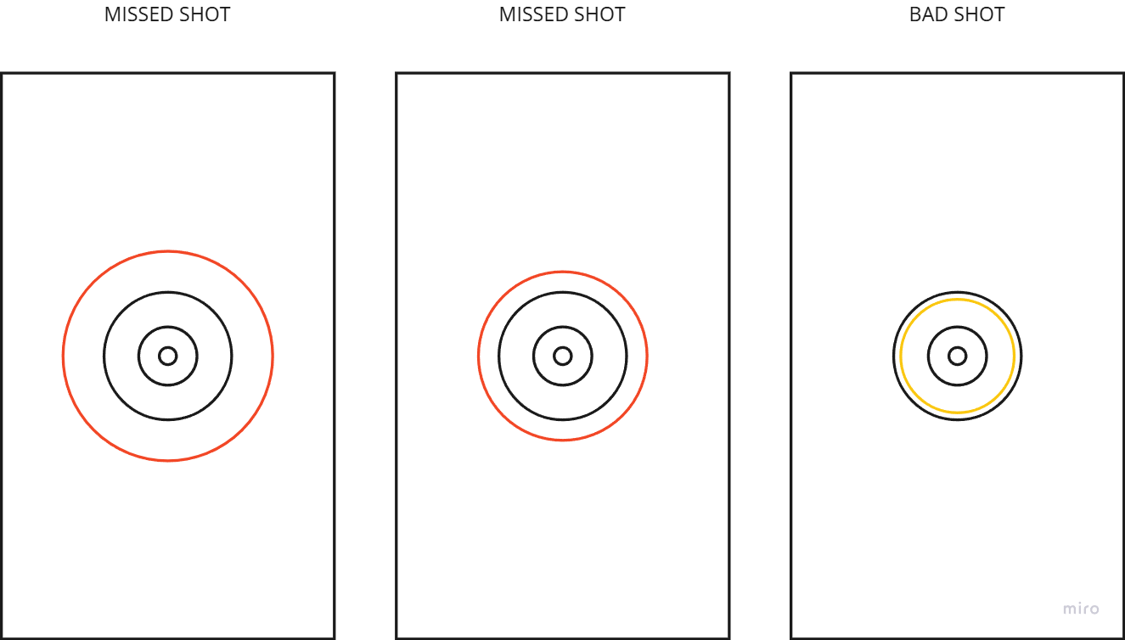

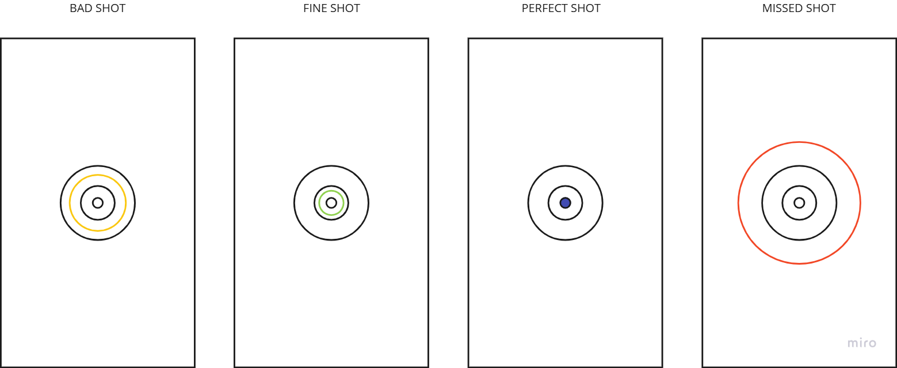

Tasks
- Implement Proposal 1

Low Powered Shots not registering
When trying to shoot with a low power % , shots fail to register around 30% of the time. This has been reported as a bug but might be related to the Control Lag point below. In any case, it needs to be addressed.

Tasks
- Find out where the min power is set up
- Tweak it
- Change Shot Restricted color to (TBD)
- Club Control Sprite moves slightly up
- Restricted shot path color

Aiming Circle Speed
The rhythm of our “Hit window” (the speed in which the green circles move towards the ball) is currently too fast, which makes it very hard to pull off a good shot.

Task
- Tweak Hit Window base speed

Aiming Circle Relative Size
The outer circle should be bigger than the inner circle.

- Tweak Aiming Reticles relative size

Aiming Circle Acceleration
As a user I want the difficulty of the shot to increase if I use too much power, so I feel i have to measure risk against reward on each shot
- Parameter in unity to increase/decrease speed relative to power divided in:
  - % speed increase per % over a 100% with separate debug option to turn off in game)
  - % decrease per % under 100% with separate debug option to turn off in game)
Experimental values for all percentages can be 1% but subject to change

Task
- Aiming Circles Acceleration

Control lag
While pulling back the club works flawlessly, moving “up” to hit the ball response is not real time and the last stretch is done in slow motion. It feels off. If this was a design decision, what was the rationale behind it?

Note: Bug, the club control sprite should grow smaller when moving towards the ball as it grows bigger when pulling away from it.

Also, in golf, the club moves slow at the beginning and faster as it gets closer to the ball. So this mechanic should be flipped.

Tasks
- Debug Option to turn off acceleration/deceleration altogether
- Flip acceleration so the club gets “shot” from the player’s finger and accelerates near the ball.

Yard Meter
Currently we only show % of a shot's power. This leads to users always trying to do 120% shots, which is not as intended. A small test revealed that adding a yards number under the power % can help solve this issue.

Tasks
- Add Yard Meter for shots

Max Power missing 1% while using Putter
This seems to be a bug.

Tasks
- Fix Max Power bug

Reduce Randomizing factor
In order to reduce the incidence of randomness on each shot, the Randomizer value for clubs formulas (Randomizer in Game Play Formulas Sheet) should be reduced from current 1-15 to 0-3.
Current
“Final Shot distance = (Base distance of club based on rarity + (club power parameter/2) + base Str of character based on rarity + (chara STR parameter/2) + (5% of spin parameter value*spin input)+ball power parameter (if any) + randomizer (number from 1 to 15))*penalty from green ring
Updated
“Final Shot distance = (Base distance of club based on rarity + (club power parameter/2) + base Str of character based on rarity + (chara STR parameter/2) + (5% of spin parameter value*spin input)+ball power parameter (if any) + randomizer (number from 0 to 3))*penalty from green ring

Tasks
- Change Randomizer

Flight Path
Players don’t understand why the ball wouldn't fly as they wished.
The game draws a visible line to show how the finger moved. The line can disappear right after the clubhead hits the ball.

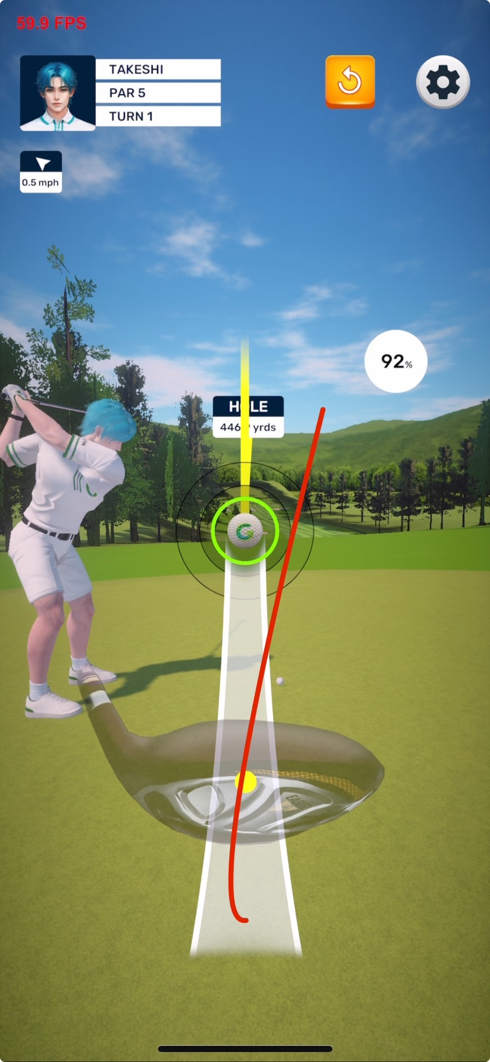

Tasks
- Implement Flighpath design

Direction
The direction the ball is hit right now depends on more than one user input.
- First it’s the Zone drop from the map view
- Second is the direction given by sliding the finger and repositioning the golfer
- Third is the error introduced by bad flicking
- Fourth is the error margin added by a bad shot and the club rarity

Tasks
- Reduce available slide size (Tentative: 25 degrees each side)

All tasks in order of priority
- Implement Proposal 1
- Find out where the min power is set up
  - Tweak it
- Tweak Hit Window base speed
- Tweak Aiming Reticles relative size
- Club Control Sprite moves slightly up
- Debug Option to turn off acceleration/deceleration altogether
- Aiming Circles Acceleration
- Flip acceleration so the club gets “shot” from the player’s finger and accelerates near the ball
- Change Randomizer
- Add Yard Meter for shots
- Restricted shot path color
- Fix Max Power bug
- Reduce available slide size
- Implement Flighpath design

